Screenshots of current ClaimResponse resource reads functioning normally.

Here id2

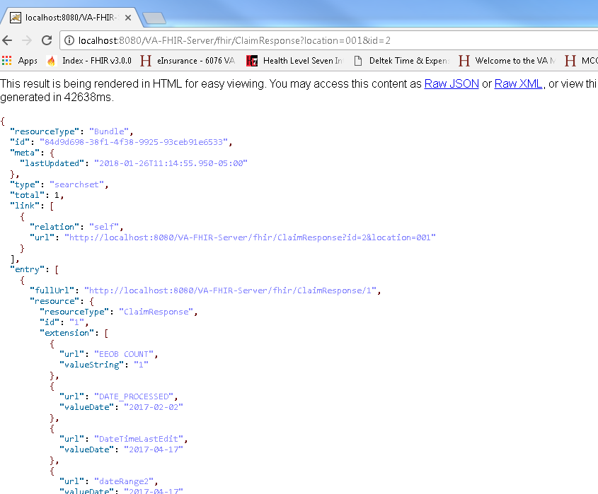

Here id1

